Key information for Professionals
Who we are

Sapphire Partnership was created by Dee Luczka, Jen McVeigh and Liz Davies. We are people who appreciate every person for the gem they are and who can see the potential growth and development. We want to create an environment which is accessible all year round, where young adults with additional needs can feel valued and listened to and can contribute to the wider community. To support this process we will work in partnership with their families and professionals in order to build a lasting legacy.
We have a passion for working together to embrace opportunities which support young adults with additional needs holistically.
Our intended impact is for young adults with additional needs between the ages of 18 and 35 to be more confident, resilient and independent individuals who are empowered to reach their potential. We are based in Bolton town centre.
Our Purpose is to…

Support young adults with additional needs to embrace all aspects of their life by encouraging communication, mindfulness and independence whilst building social skills and self-development.
Work alongside a range of professionals eg social care, health and DWP who will help us to enhance our holistic approach to support young adults with additional needs and their families.
Facilitate a safe forum for family members of young adults with additional needs to share their personal experiences and offer opportunities to learn and develop from each other.

Our Vision

‘Building a legacy for young adults with additional needs’
L – Life skills development that will equip young adults for life
E – Empowering young adults to be part of influencing a positive change
that improves their wellbeing
G – Guiding young adults to make informed choices about their future
A – Aspirational goals to encourage young adults to achieve more
C – Community involvement and encourage a sense of belonging with other
young adults
Y – Young adult centred by encouraging them to develop their skills to be
the best they can be
Our experience

The Directors at Sapphire Partnership have a wealth of experience and qualifications in a number of key areas which contributes to our offer:
- Youth work
- Teaching
- Leadership and administration
- Working with children and young adults with additional needs and disabilities
- Working alongside Social Care and Health professionals
- Working with families, parents and carers
What we know works well

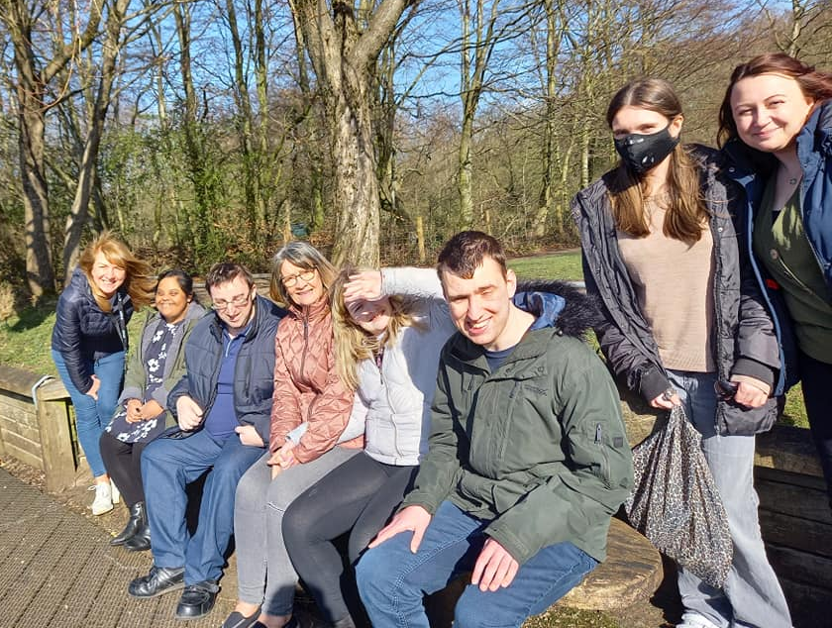

Socialisation with peers and the wider community

A relaxed and friendly approach
A safe and encouraging environment

Young adult with additional needs

Flexibility to change with the needs of the young adult
Listening to the views of the young adult and the family

Promoting positive mental health and wellbeing

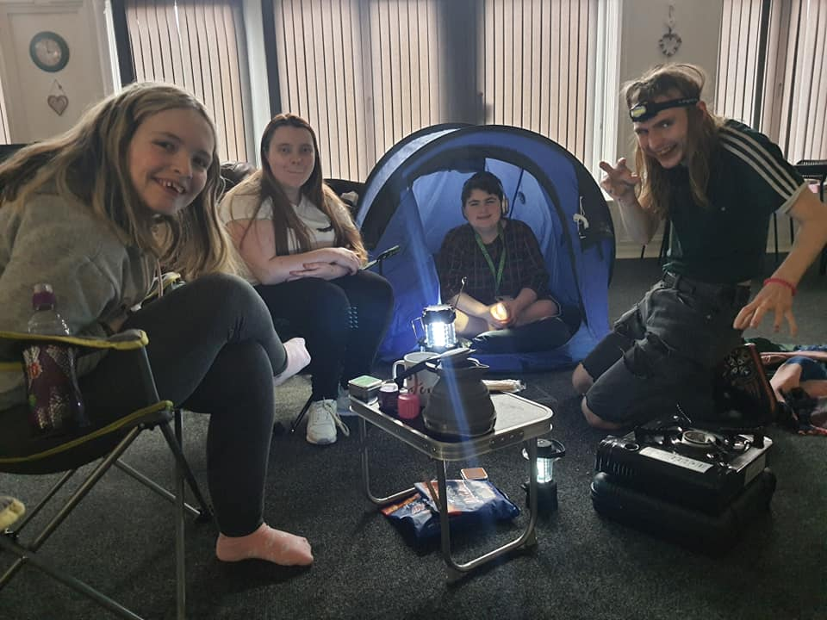

How we deliver our vision

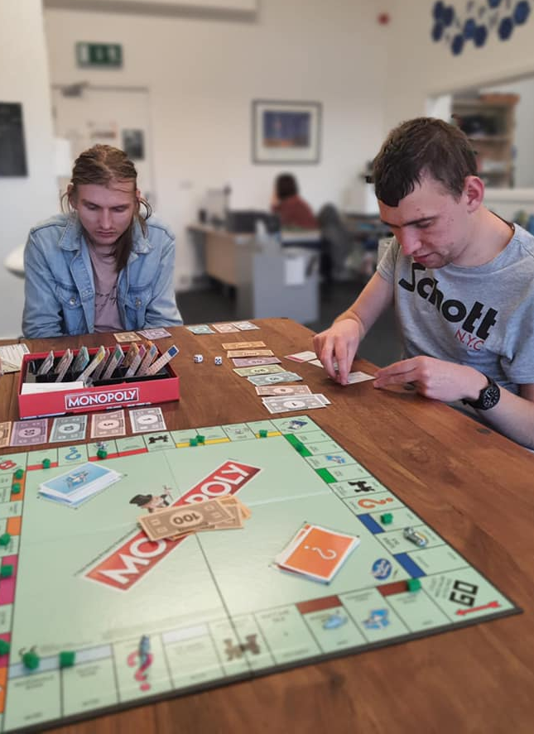
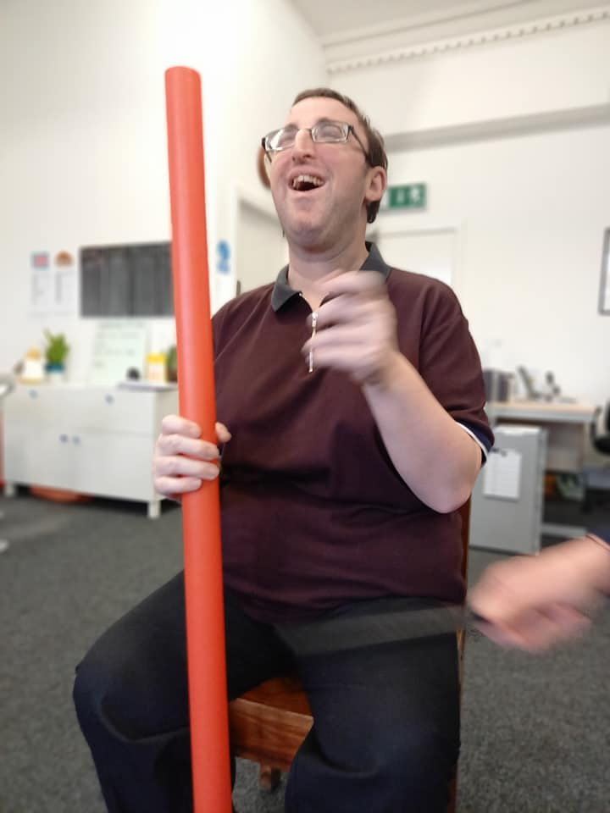
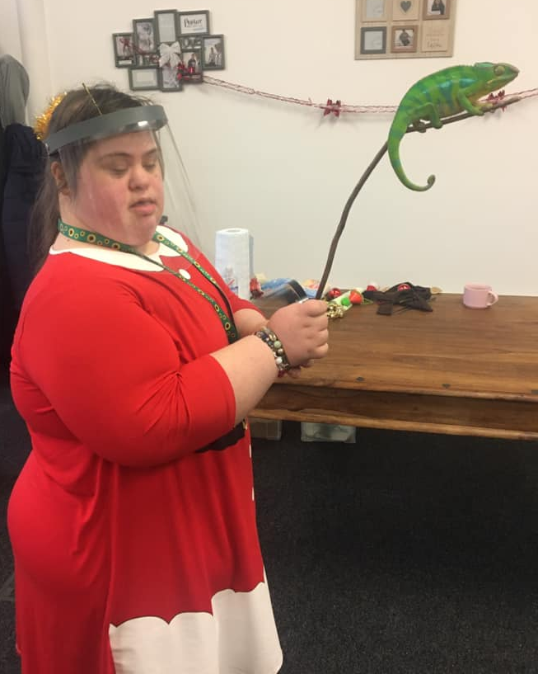

We will work alongside young adults with additional needs to provide:
- Daily sessions offering a range of activities which promote communication and independence skills, eg decision making, planning activities, teambuilding and group work
- Development of life skills that can be easily transferred into daily routines, eg budgeting, shopping, cooking, home skills.
- Support at appointments, meetings and other specific events
- Evening social groups, eg karaoke, dance and games
- Residential experiences
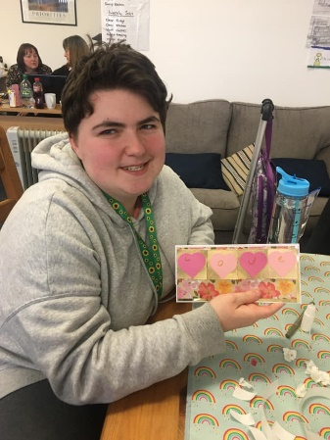
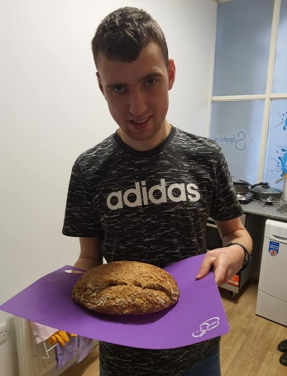
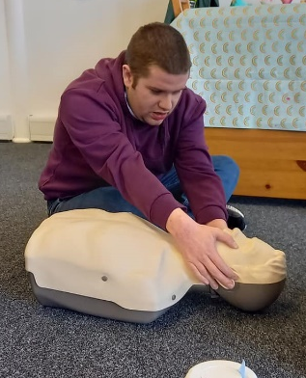

We will work alongside families to provide:
- Group support
- Evening events offering support and professional advice
- Support at appointments, meetings and other specific events
- Opportunities for volunteering and involvement at Sapphire

We will work alongside professionals to facilitate:
- A joint approach that benefits the young adult and their family
- An environment where services can meet and plan with families
- Training events
Application Process

Have a look at our social media and website www.sapphirepartnership.com
Sapphire Partnership Sapphire Bolton Sapphire_Partnership

Fill in the application form attached, send it to Sapphire and arrange a visit.
2nd floor St Georges House, 2 St Georges Road, Bolton, BL1 2DD
admin@sapphirepartnership.com
01204 399504

Ensure funding to attend Sapphire Partnership is secured.

We look forward to you starting at Sapphire!
Sapphire Partnership Application Form

Criteria for applying to Sapphire Partnership (please tick)
You must be aged between 18 and 35

You must have one of the following
(please provide us with a copy):
Social care plan
EHCP
Statement of needs or LDA
Health needs plan

Applicant Name:___________________________________________________________________
Address:__________________________________________________________________________
_________________________________________________________________________________
Phone:________________________________ Mobile:_____________________________________
Date of Birth: ____/____/____ National Insurance Number:_______________________________
Contact email:_____________________________________________________________________
Name of Emergency Contact:____________________________ Relationship:__________________
Emergency contact number:__________________________________________________________
Brief details of support required whilst attending Sapphire: __________________________________
_________________________________________________________________________________
_________________________________________________________________________________
Name of social worker (if applicable): ___________________________________________________
Requested Start Date at Sapphire:_______________________________
Please tick the days you would like to attend on a weekly basis, Sapphire’s day rate is £65.

 | Monday | Tuesday | Wednesday | Thursday | Friday
10am – 4pm
Open from 9.30am for breakfast club

Do you have a payment method set up (eg direct payments, personal budget)? If so, which method?
________________________________________________________________________________

Applicants signature:_________________________________ Date:__________________________

