


Sapphire Partnership
Building a legacy for young adults with neurodiverse needs and disabilitie

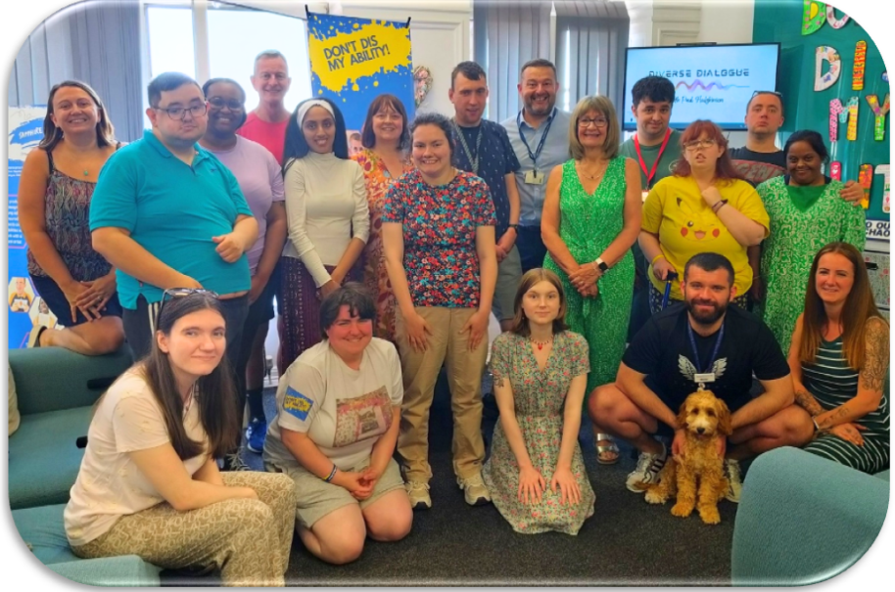



St Georges House, 2 St Georges Road, Bolton, BL1 2DD Tel: 01204 399504 Email: admin@sapphirepartnership.com

Information for Young Adults
Who we are



Dee Jen Liz

 We see every person for the gem they are. We want to create an
environment where you feel valued and heard. We also want to ensure
that you have opportunities to experience different activities and contribute to the wider community.

We are passionate about working together with others so that you can have the best possible time at Sapphire, as well as a highly fulfilled life.

We work in partnership with parents, carers and families, as well as working alongside social workers and health professionals.

We aim to provide support for young adults to live more independent lives by working on important life skills such as communication, interaction, teamwork, safety and appropriateness whilst accessing
community activities. We also provide the learning necessary for home skills such as cleaning, cooking and overall kitchen safety.


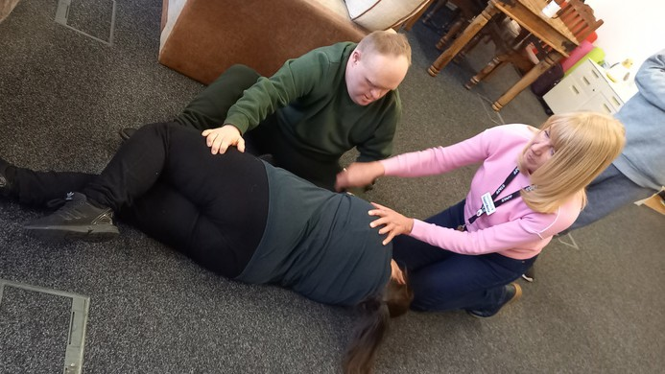
Specific courses for life such as first aid

Our Offer
At Sapphire Partnership we offer a range of activities and varied experiences all year round for young adults with neurodiverse needs and disabilities, aged between 18 and 40
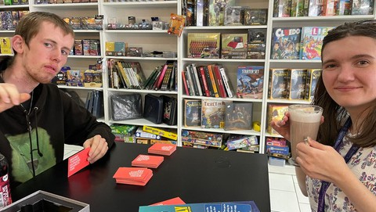
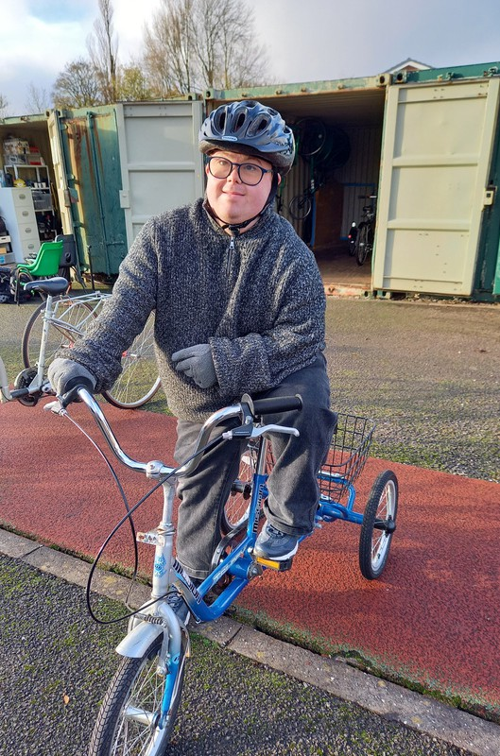
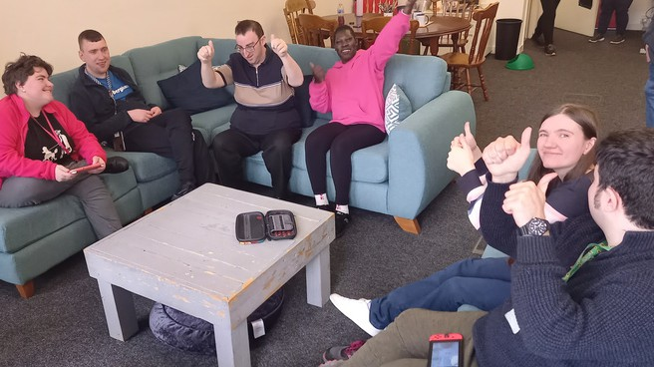
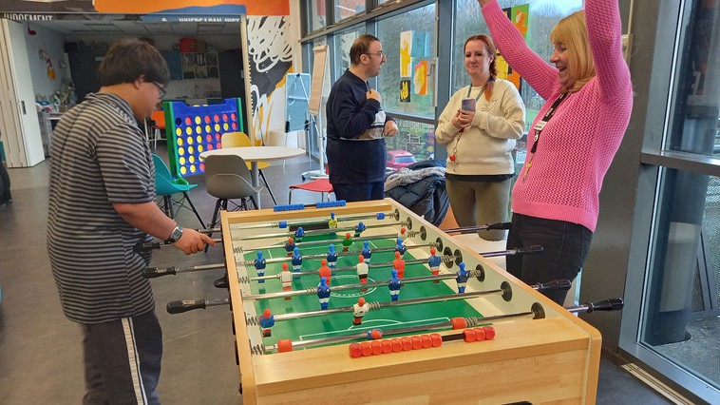
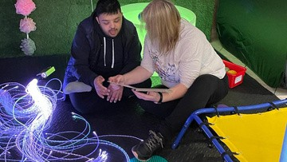
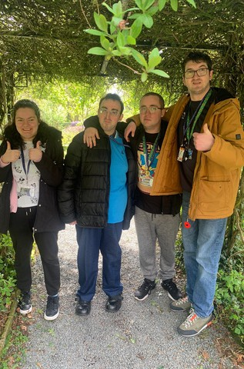
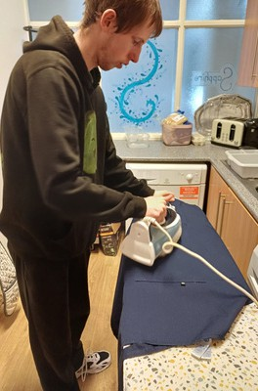
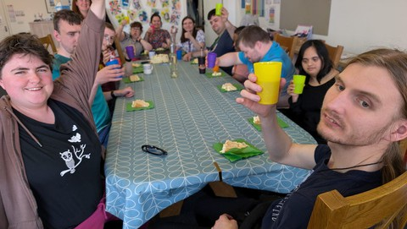
Access to a range of activities in the community
Support with health and fitness
A warm, friendly and safe place to be with a family atmosphere
Experiencing social groups and building peer support
Strengthening communication and mindfulness skills

Building friendships
Life skills such as cooking, cleaning and budgeting
Being listened to and asked your opinions
Designing products
Organising them to sell
Running stalls

Opportunities
Residential
We run residential experiences each year which allow the young adults to experience staying away from home and spending time away with friends.
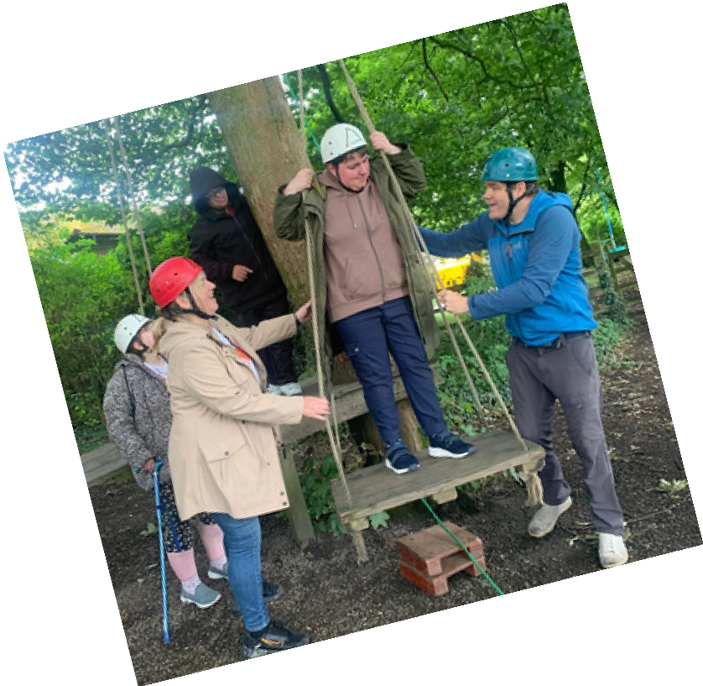
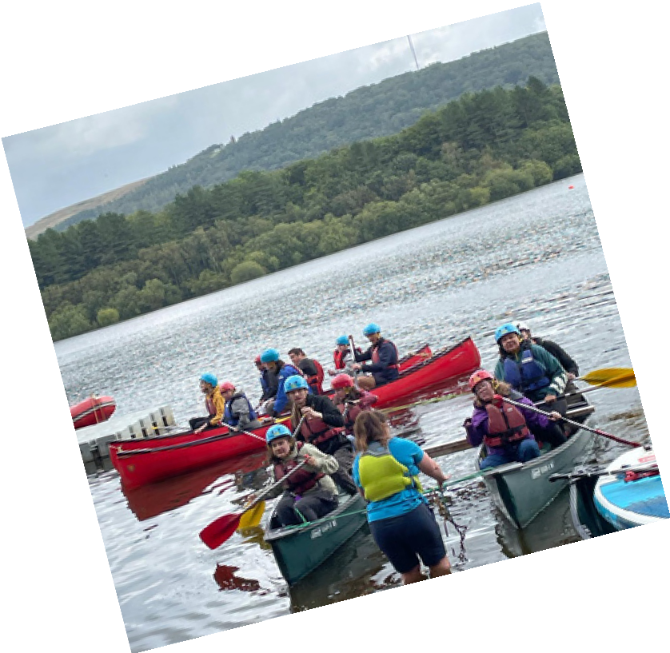
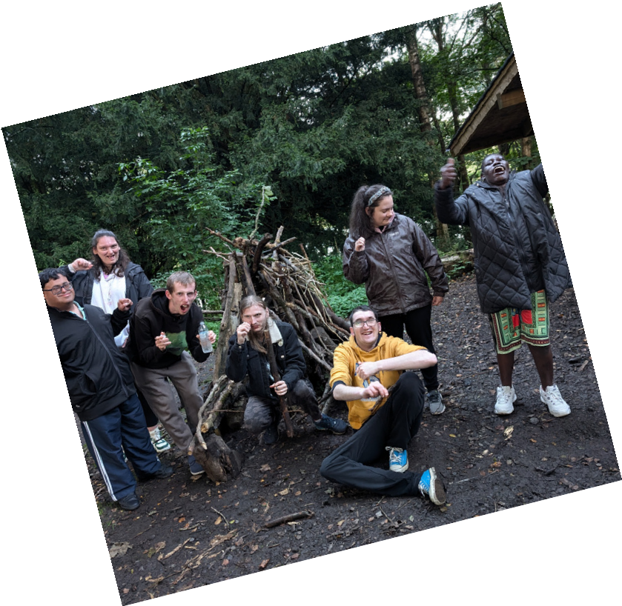
During these experiences we usually take part in outdoor activities and practice skills which improve your independence.

Social Enterprise
Supporting each other
Trying new skills
Team work and
challenging each other
We work with a local artist to produce a range of products to sell. We currently have a page on our website where we sell items and sometimes run stalls at
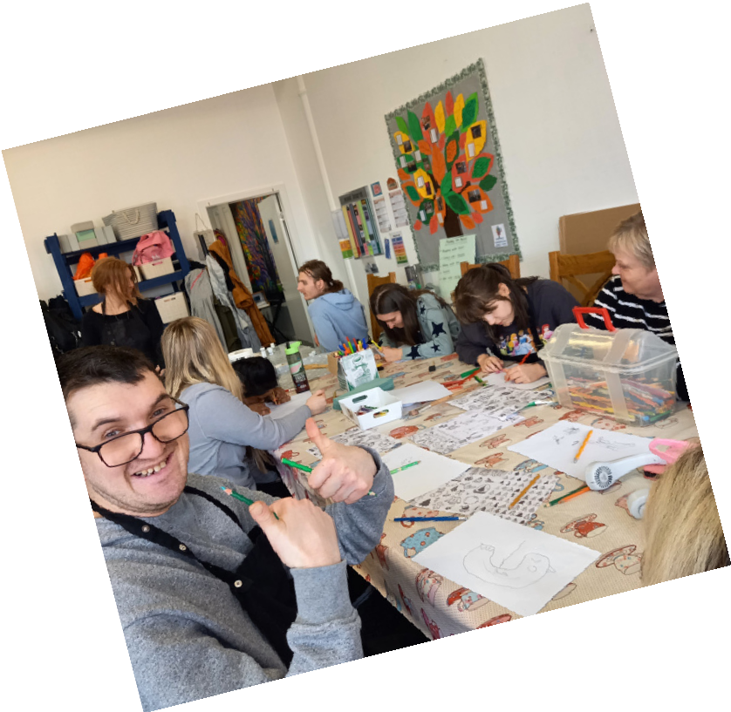

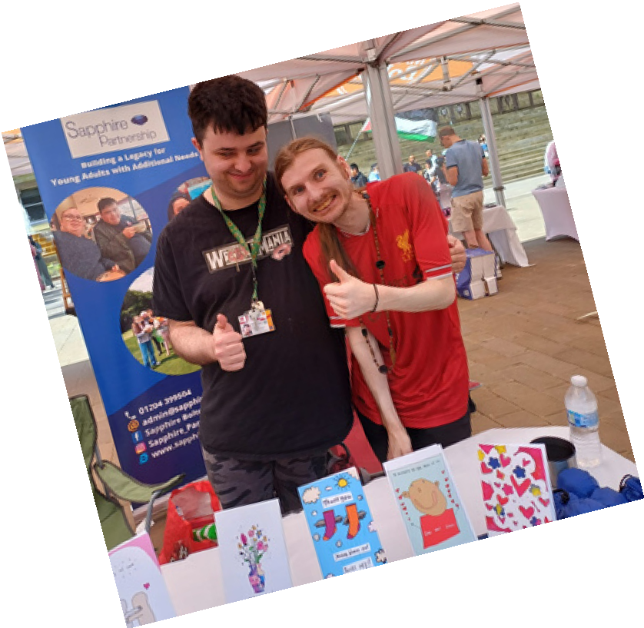
events. We have a small group of young adults who manage the finances, stock ordering and marketing.









