# Sapphire Partnership

## Building a Legacy for young adults with additional needs

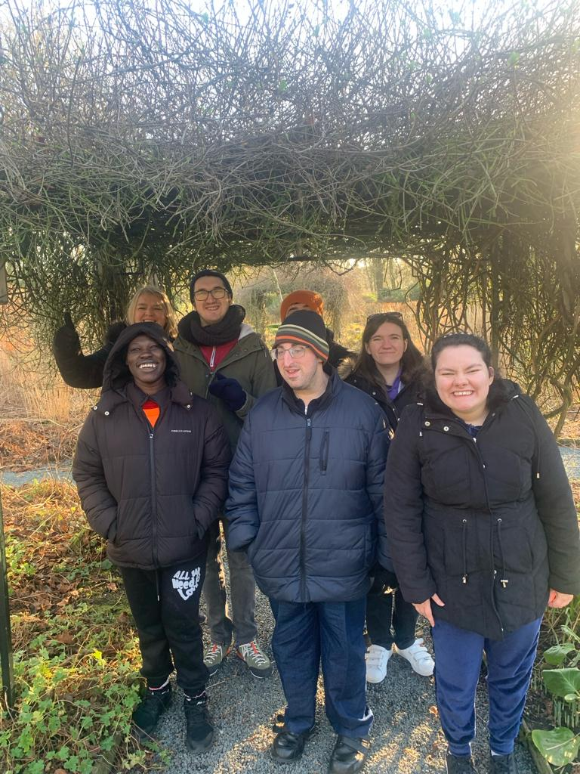

# Sapphire Partnership Application Form

We want you to know that you are very welcome to come and visit us at Sapphire Partnership and can arrange to do so by contacting ourselves on our landline; **01204 399504**.

If you would like to apply, please complete all the sections of the form below and return it to: **Sapphire Partnership, 2nd floor, St Georges House, 2 St Georges Road, Bolton, BL1 2DD**.

Alternatively, you can scan and email it over to us at: [**admin@sapphirepartnership.com**](mailto:admin@sapphirepartnership.com).

Please fill in all the requested forms below, as we cannot offer a position at Sapphire unless we receive of your information completed.

**Application Criteria** (please tick)**:**

You must be aged between 18-40

You must have **one** of the following:

Social Care Plan

EHCP

Statement of Needs/LDA

Health Needs Plan

(Please fill in on the lines provided below)

**Applicant Details:**

|  |  |  |  |  |
| --- | --- | --- | --- | --- |
| Name: |  | |  |  |
| Address: |  | |  |  |
|  |  | |  |  |
| Contact Number: |  | |
|  |  | |  |  |
| Contact Email: |  | | | |
|  |  | |  |  |
| Date of Birth: |  | |
|  |  | |  |  |
| National Insurance Number: | |  |

**Emergency Contact #1 Information:**

|  |  |  |  |
| --- | --- | --- | --- |
| Name: |  |  |  |
|  |  |  |  |
| Contact Number: |  |
|  |  |  |  |
| Relationship: |  |  |  |

**Emergency Contact #2 Information:**

|  |  |  |  |
| --- | --- | --- | --- |
| Name: |  |  |  |
|  |  |  |  |
| Contact Number: |  |
|  |  |  |  |
| Relationship: |  |  |  |

**Additional Information:**

|  |  |  |  |
| --- | --- | --- | --- |
| Support Requirements: |  | | |
|  | | | |
|  | | | |
|  | | | |
|  |  |  |  |
| Name of Social Worker: |  |  |  |
| (‘N/A’ if not applicable) | | | |
|  |  |  |  |
| Requested Start Date: |  |
|  |  |  |  |

**Please tick the days you would like to attend on a weekly basis:**

|  |  |  |  |  |
| --- | --- | --- | --- | --- |
|  | **Monday** | **Tuesday** | **Wednesday** | **Thursday** |
| **10:00am – 4:00pm** |  |  |  |  |

**We are open from 09:30am every day for breakfast club.**

**Sapphire’s day rate is £71.50.**

|  |
| --- |
| Do you have a payment plan set up (e.g., direct payments, personal budget)? |
| If so, which method? |
|  |

|  |  |  |  |
| --- | --- | --- | --- |
| Applicant Signature: |  | Submission Date: |  |

# Key Information

## **Health**

Please tick the boxes which are applicable:

|  |  |
| --- | --- |
| Disability/Additional Needs | Tick |
| Developmental – e.g., ADHD, Autism, Dyspraxia |  |
| Injury – Body, Brain |  |
| Physical – e.g., Down Syndrome, Cerebral Palsy, Dystrophy |  |
| Medical – e.g., Allergies, Asthma, Diabetes, Epilepsy, ME |  |
| Mental Health – e.g., Depression, Self-Harm, Eating Disorder |  |
| Sensory – e.g., Hearing, Vision, Touch |  |
| Behavioural – e.g., Aggressive, Emotional |  |

|  |  |
| --- | --- |
| Please provide additional details below: |  |
|  | |
|  | |
|  | |
|  | |
|  | |

|  |  |
| --- | --- |
| Please provide any medical conditions: |  |
|  | |
|  | |
|  | |
|  | |
|  | |

Is the applicant able to self-administer medication if required? **Yes** / **No**

|  |  |
| --- | --- |
| Please specify if any medication is taken: |  |
|  | |
|  | |
|  | |

**If medication is taken during the hours at Sapphire or if emergency medication may need to be administered, please fill in a medication form. All medication including over the counter medication must be clearly labelled by the parent or carer.**

Are there any medical professionals involved with the applicant? **Yes** / **No**

**If so, please fill in their details below:**

|  |  |  |  |  |
| --- | --- | --- | --- | --- |
| Name: |  | |  |  |
|  |  | |  |  |
| Contact Number: |  | |  |  |
|  |  | |  |  |
| Involvement Details: | |  | | |
|  | | | | |
|  | | | | |
|  | | | | |

|  |  |
| --- | --- |
| Does the applicant have any dietary requirements? |  |
|  | |
|  | |

Does the applicant have any allergies? **Yes** / **No**

|  |  |
| --- | --- |
| If so, please provide details: |  |
|  | |
|  | |

## **Safeguarding**

Photos will be taken for the Sapphire scrapbook and may also be used on the Sapphire Partnership social media sites and website. Please speak to a member of staff if you have any concerns about this.

If you have any ongoing safeguarding concerns that staff need to be aware of, please speak to our Designated Safeguarding Lead.

## **Additional Information**

Please provide information on anything else you feel we need to know in order that we can provide the best support to enhance their personal development (for example, key areas of need, specific support that may be required, personal targets to be worked on, communication preferences, likes and dislikes) etc:

|  |
| --- |
|  |
|  |
|  |
|  |
|  |
|  |
|  |
|  |
|  |

|  |  |
| --- | --- |
| Date: |  |
|  |  |
| Parent/Carer Signature: |  |
|  |  |
| Young Person Signature: |  |

Before you return the form to us, please ensure everything applicable has been completed and fully detailed. If there are unapplicable sections to the applicant, please input ‘**Not Applicable’** or **‘N/A’**.