# Sapphire Partnership

## Building a Legacy for young adults with additional needs

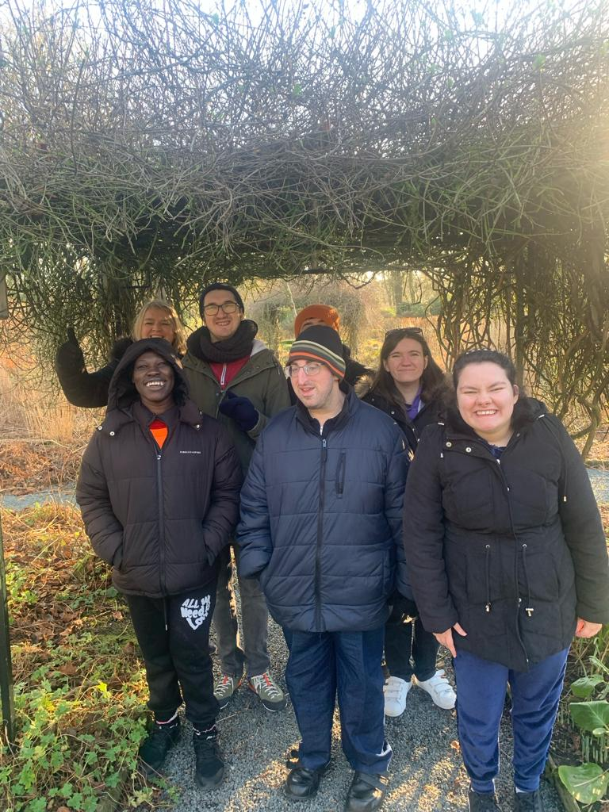

# Key Information for Professionals

## **Who We Are**

Sapphire Partnership is charity based in the local town of Bolton, initially founded in 2020 by Dee Luczka, Jen McVeigh, and Liz Davies. We deliver a programme that supports young adults with neuro diverse needs and disabilities aged between 18-40. We value and appreciate every person who attends Sapphire for the ‘gem’ they are, which is why we consistently strive to support each individual to increase the life skills they need to be as independent as they can be.

Our ambition has driven us to create an environment which is accessible throughout the whole year which provides continuity and increased opportunity. We ensure that our young adults feel valued and heard by undertaking a comprehensive assessment prior to engaging with us where they have the opportunity to express their views. The programme provides a platform where they can contribute to service improvement as they help to design and plan the activities.

We actively contribute to the wider community around us by supporting local businesses, establishing good relationships with our partners, and paying forward as much as we receive. We work in partnership with the families and professionals to support this process and build a legacy that will thrive.

We are exceptionally passionate about working together so that the young adults do not create an over dependency on single services for support. We embrace new opportunities to further support our young people with additional needs in a holistic way.

Our intentions are to significantly impact the lives of young adults with additional needs between the ages of 18-40, and improve their confidence, resilience, and independence, as well as uplifting and empowering them to reach their potential.

## **Our Purpose**

* Supporting young adults with neuro diverse and disabilities needs to embrace all aspects of their life.
* Encouraging effective communication, mindfulness, and independence.
* Building social skills and self-development.
* Facilitating a safe forum for the family members of the young adults
* Encouraging them to share their personal experiences.
* Offering opportunities to learn and develop from each other.
* Working alongside a range of professionals (social care, health and DWP).
* Building relationships to assist us in enhancing our holistic approach to supporting young adults with neuro diverse needs and disabilities and their families.

## **Our Vision**

***‘Building a legacy for young adults with additional needs.’***

L: Life skills development that will equip young adults for life

E: Empowering young adults to be part of influencing a positive change that improves their wellbeing

G: Guiding young adults to make informed choices about their future

A: Aspirational goals to encourage young adults to achieve more

C: Community involvement and encourage a sense of belonging with other young adults

Y: Young adult centred by encouraging them to develop their skills to be the best they can be

## **Our Experience**

The team at Sapphire Partnership have a wealth of experience and qualifications in numerous key areas, in which contributes to our offer:

* Youth work
* Teaching
* Leadership
* Management
* Administration
* Working with children and young people with additional needs and disabilities
* Working alongside social care and health professionals
* Working with families, parents, and carers

**Working with Young Adults with Additional Needs**

**Socialisation with peers and the wider community**

**community**

**Young** **Adults with Additional Needs**

**A safe and encouraging environment**

**A relaxed and friendly approach**

**Flexibility to change with the needs of the young adult**

**Listening to the views of the young adult and the family**

**Promoting positive mental health and wellbeing**

## **Delivering Our Vision**

We work alongside young adults with neuro diverse needs and disabilities needs to provide:

* Daily Sessions offering a range of activities which promote communication and independence skills, such as decision making, planning activities, teambuilding and groupwork.
* Development of life skills that can be easily transferred into daily routines, such as budgeting, shopping, cooking, volunteering, and additional home skills.
* **A person and person holding food

  Description automatically generated**Support at appointments, meetings, and other specific events.
* Evening social groups, such as karaoke, dancing, and games.
* Residential experiences.

We will work alongside families to provide:

* Group support.
* Events offering support and professional advice.
* Support at appointments, meetings, and other events.
* Opportunities such as volunteering and involvement at Sapphire.

We will work alongside professionals to facilitate:

* A joint approach that benefits the young adults and their families.
* An environment where services can meet and plan with families.
* Training events.

## **Application Process**

Before applying for a position of partnership with us, please do not hesitate to check out our social media accounts or our website and share the information with the young adults and the families:



[www.sapphirepartnership.com](http://www.sapphirepartnership.com)



Sapphire Bolton



Sapphire_Partnership

Please see the attached application form below. You will be required to complete this form and then send it to our administrative email address provided.

Please see the attached application form below. You will be required to complete this form and then send it to the email address below.

Email: [admin@sapphirepartnership.com](mailto:admin@sapphirepartnership.com)

Additionally, once completed, you can also arrange a visit with us.

2nd Floor; St. George’s House, St. George’s Road, Bolton, BL1 2DD

Contact us: 01204 399504

Please ensure funding to attend Sapphire is in place before starting.

!

# Sapphire Partnership Application Form

**Application Criteria** (please tick)**:**

You must be aged between 18-40

You must have **one** of the following:

Social Care Plan

EHCP

Statement of Needs/LDA

Health Needs Plan

(Please fill in on the lines provided below)

**Applicant Details:**

|  |  |  |  |  |
| --- | --- | --- | --- | --- |
| Name: |  | |  |  |
|  |  | |  |  |
| Contact Number: |  | |
|  |  | |  |  |
| Contact Email: |  | | | |
|  |  | |  |  |
| Date of Birth: |  | |
|  |  | |  |  |
| National Insurance Number: | |  |

**Emergency Contact Information:**

|  |  |  |  |
| --- | --- | --- | --- |
| Name: |  |  |  |
|  |  |  |  |
| Contact Number: |  |
|  |  |  |  |
| Relationship: |  |  |  |

**Additional Information:**

|  |  |  |  |
| --- | --- | --- | --- |
| Support Requirements: |  | | |
|  | | | |
|  | | | |
|  | | | |
|  |  |  |  |
| Name of Social Worker: |  |  |  |
| (‘N/A’ if not applicable) | | | |
|  |  |  |  |
| Requested Start Date: |  |
|  |  |  |  |

**Please tick the days you would like to attend on a weekly basis:**

|  |  |  |  |  |
| --- | --- | --- | --- | --- |
|  | **Monday** | **Tuesday** | **Wednesday** | **Thursday** |
| **10:00am – 4:00pm** |  |  |  |  |

**We are open from 09:30am every day for breakfast club.**

**Sapphire’s day rate is £71.50**

|  |
| --- |
| Do you have a payment plan set up (e.g., direct payments, personal budget)? |
| If so, which method? |
|  |

|  |  |  |  |
| --- | --- | --- | --- |
| Applicant Signature: |  | Submission Date: |  |