# Sapphire Partnership

## Building a Legacy for young adults with additional needs

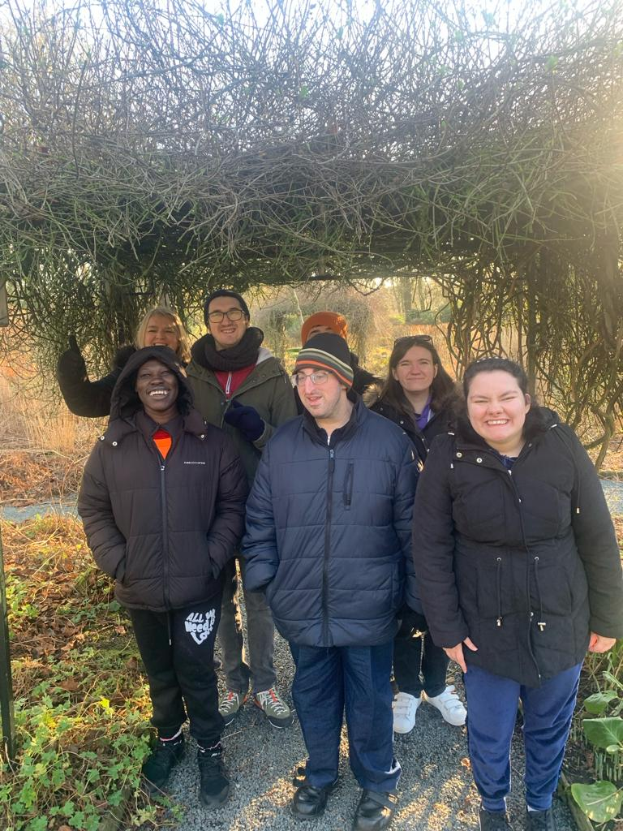

# Information for Young Adults

**Who We Are**

* We are Dee, Jen and Liz; and we see every person for the ***gem*** they are. We want to create an environment where you feel ***valued*** and heard. We also want to ensure that you have ***opportunities*** to experience different activities and contribute to the wider community.
* We are ***passionate*** about working ***together*** with others so that you can have the best possible time at Sapphire, as well as a highly fulfilled life.
* We also work in ***partnership*** with parents, carers and families, as well as working alongside social workers, health professionals and more to ***support*** you in all aspects of your life.
* We aim to provide support for young adults to live more ***independent*** lives, by working on ***life skills*** such as communication, interaction, teamwork, safety and appropriateness whilst accessing ***community*** activities. In addition, we intend to provide the learning necessary for home skills too, such as cleaning, cooking and overall kitchen safety.

## **Our Offer**

At Sapphire Partnership, we offer a range of activities and experiences all year round for young adults with additional needs, aged between 18-40 years old.

So, what do we offer?

In addition to this, we also offer support and opportunities to parents, carers and families of young adults with additional needs.

* We provide a chance to be a part of a forum with other families to connect with.
* We host evening events, provide professional advice and volunteering opportunities.
* A person sitting at a table with a drawing

  Description automatically generatedA person smiling at camera

  Description automatically generatedA person drawing on a clear board

  Description automatically generatedA person and person holding food

  Description automatically generated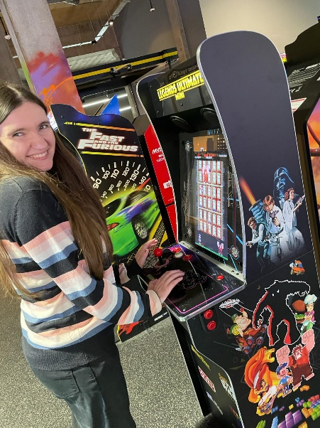A person on an exercise bike

  Description automatically generatedWe provide support at meetings and appointments.

